**SOIL MOISTURE SENSOR:**

The soil moisture sensor is one [kind of sensor](https://www.elprocus.com/accelerometer-sensor-working-and-applications/) used to gauge the volumetric content of water within the soil. As the straight gravimetric dimension of soil moisture needs eliminating, drying, as well as sample weighting. These sensors measure the volumetric water content not directly with the help of some other rules of soil like dielectric constant, electrical resistance, otherwise interaction with neutrons, and replacement of the moisture content.

Soil moisture sensors **measure the water content in the soil and can be used to estimate the amount of stored water in the soil horizon**. Soil moisture sensors do not measure water in the soil directly. Instead, they measure changes in some other soil property that is related to water content in a predictable way.

The most common types of soil moisture sensors include **gypsum blocks, tension meters, capacitance, volumetric, and neutron probes**. These sensors either measure soil tension when placed in the soil or measure volumetric water content.

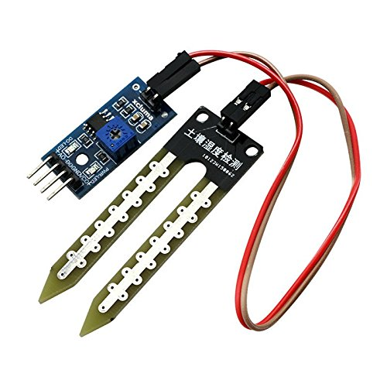

**RELAY SWITCHES:**

A relay is an **electrically operated switch**. It consists of a set of input terminals for a single or multiple control signals, and a set of operating contact terminals. The switch may have any number of contacts in multiple contact forms, such as make contacts, break contacts, or combinations thereof.

Relays are **switches that open and close circuits electromechanically or electronically**. Relays control one electrical circuit by opening and closing contacts in another circuit.

